**LAMBDA FUNCTION**

AWS Lambda is a Serverless compute service that runs code in response to events and automatically manages the underlying compute resources.

**LAMBDA ROLE**

A Lambda function's execution role is an AWS Identity and Access Management (IAM) role that grants the function permission to access AWS services and resources.

**Components of AWS Lambda**

* A function: This is the actual code that performs the task.
* A configuration: This specifies how your function is executed.
* An event source: This is the event that triggers the function. You can trigger with several AWS services or a third-party service.

**Benefits of Lambda**

* No servers to manage
* Continuous scaling
* Millisecond metering
* Increases innovation
* Modernize your applications

TASK:

[Lambda function to delete an empty S3 bucket using Boto](https://stackoverflow.com/questions/65382894/lambda-function-to-delete-an-s3-bucket-using-boto).

Created two buckets. One with data and another bucket without data.

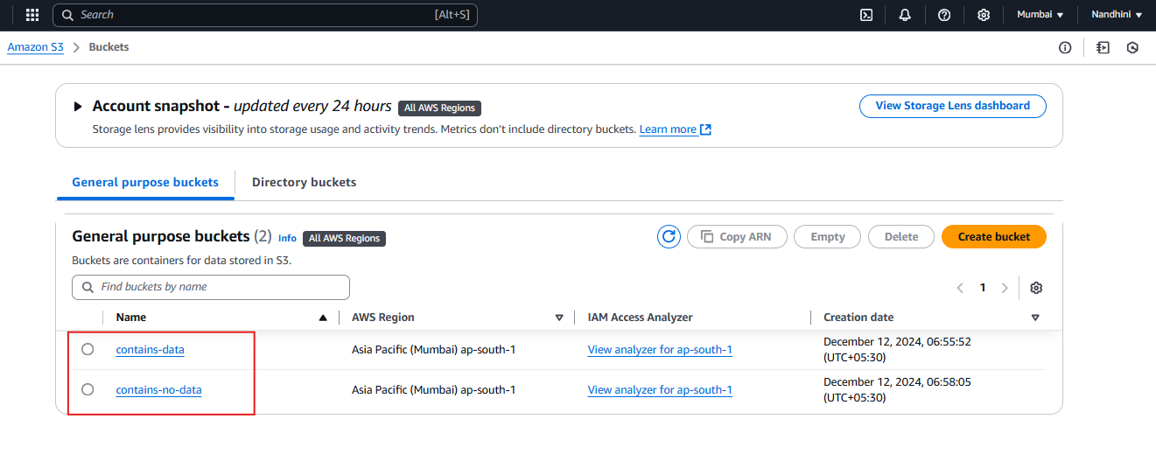

Bucket named “contains_data” has a file in it.

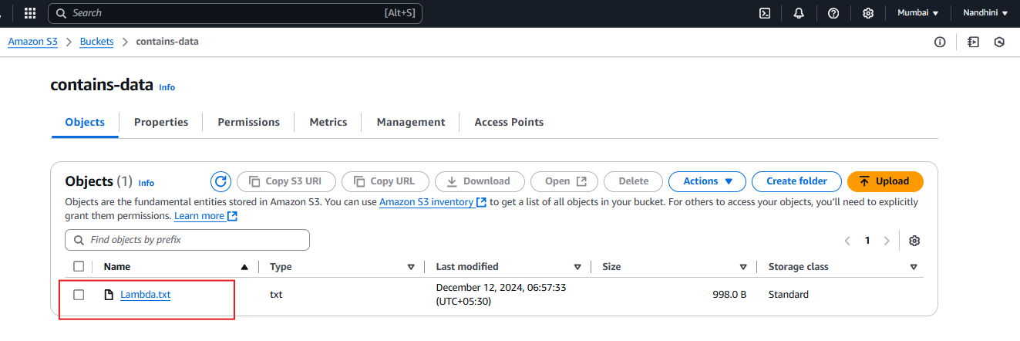

Created Lambda function.

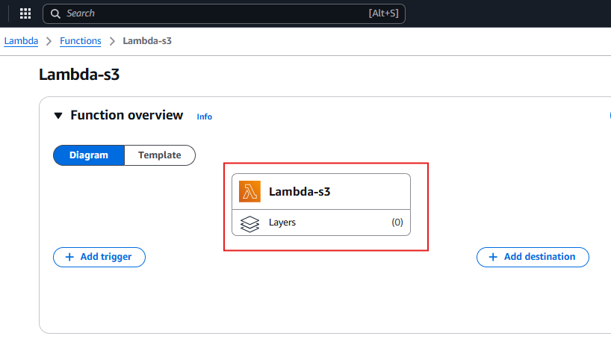

Created an event (s3_Event) and deployed a Python code in Lambda.

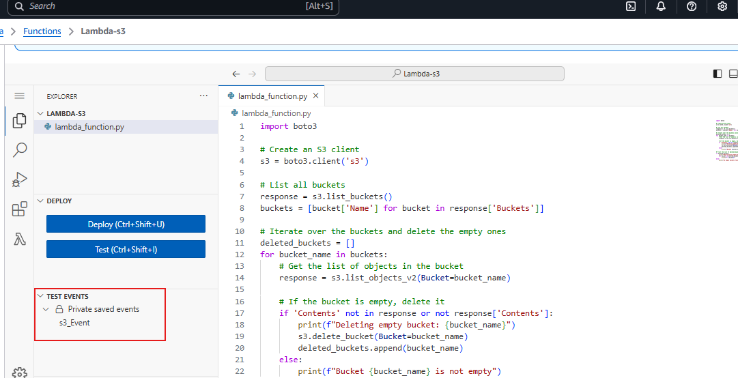

Added some permissions to access the S3 bucket.

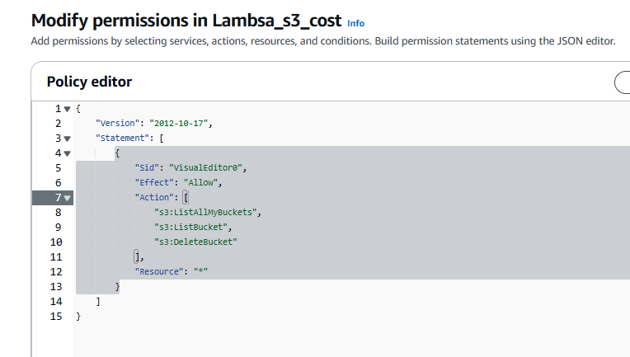

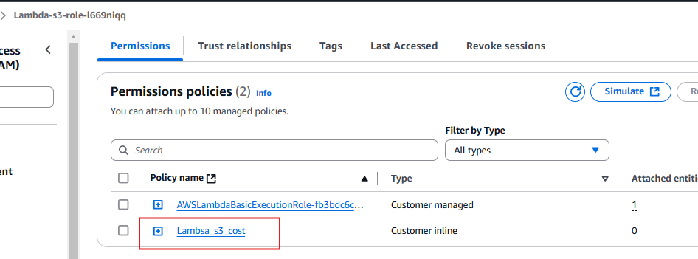

Empty bucket has been deleted successfully by lambda function:

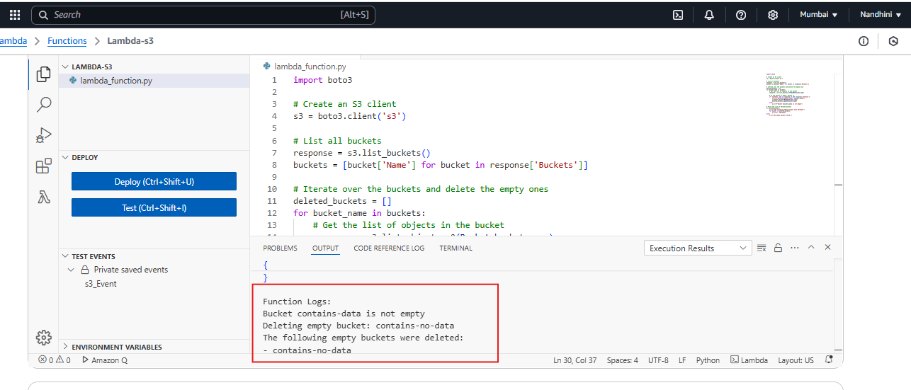

Output:

